**EXIF**

**What is metadata ?**

Metadata is data that describes other data. Put into the context of the definition, an image is itself a series of visual data. The metadata is the information that describes the properties of that image. Hence, metadata is data about data.

**EXIF**

Exchangeable image file format (EXIF) is a metadata standard that specifies the formats and properties of various media forms, such as images and voice recordings. EXIF data is created by the devices that produce these media items. The fact that EXIF is a metadata standard also means that the media item can be read by another device with no formatting issues. This is what makes it easy to transfer, download or view an image taken on an iPhone with a Samsung device.

It can be scary to see what sort of data is saved when you take a photo! If not removed, photos can include hidden information about the person who took the photo, including the make and model of the camera, the date and time of the photo, or even the location of the photo. Fortunately, most popular social media sites will now remove metadata from uploaded images, so any sensitive information is stripped from the image before being made publicly available. However, this is unfortunately not universal across all websites, so you can use image metadata viewers to see if any hidden data has been saved alongside the photo.

**How to view the EXIF data of a photo ?**

[Metadata2Go](https://www.metadata2go.com/) is one of many easily accessible online metadata viewer tools, but many other tools exist on the web to view the EXIF data of a photo. Simply upload your photo to one of these tools, and see what's been saved with the photo.

Fields contain both technical information about the photo – such as the resolution or file type of the image – but also might include sensitive information about the photographer – such as their name or location. Depending on the tool you use, these fields may be named differently, but the value will remain the same.

There are many tools on the internet that provide identical functionality; for example, [ExifData](https://exifdata.com/) and [ExifTools](https://exif.tools/) are just two (of many) alternatives.

**Walkthrough**

**Input**

Upload this image into one of the tools mentioned above ( Metadata2Go, Exifdata, ExifTools)

<https://drive.google.com/file/d/1J5fvEX6sboofxeBY_U6VjR6902My0qxK/view?usp=drive_link>

**Output**

The output shown below is all the metadata that got extracted from the input photo.

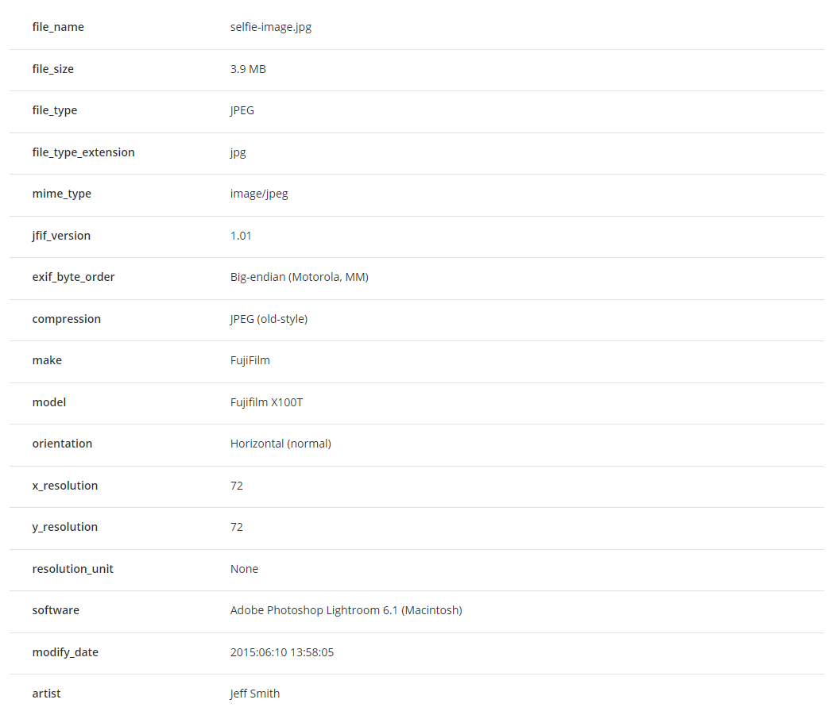

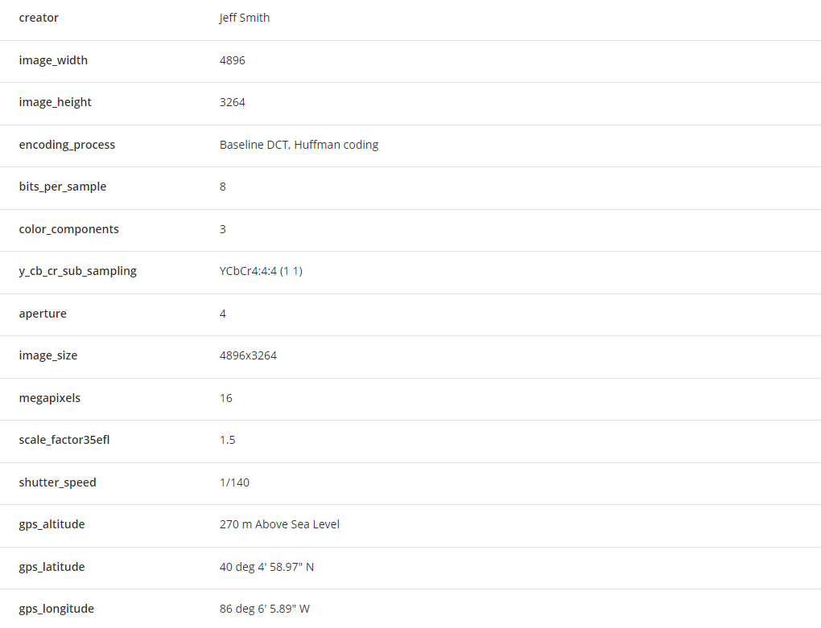

Now looking at a snippet of this table we can get to know the followings:

1. Creator or the photographer’s name is **Jeff Smith**
2. The date on which the image was taken : **2015:06:10**
3. Brand of the camera used to take the photo : **Fujifilm**
4. We can use the longitude and latitude fields in the image metadata, and use Google Maps to identify where the photo was taken.

GPS position : **4004'59.0"N 86°06'05.9"W**

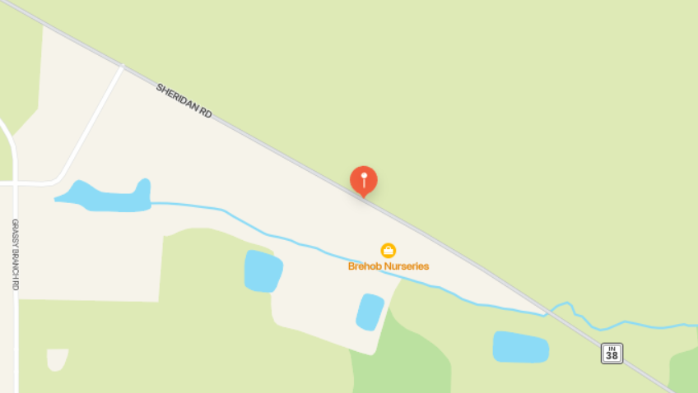

Searching this location shows that the photo was taken on **Sheridan Rd.**

Thus, Exif data embedded in digital images can inadvertently expose sensitive information. It's crucial to remove or sanitize Exif data before sharing images to maintain privacy and security.